**“Burn-Out Reminisce”**

Submitted to: Rainheart Pinuela

Submitted by:

Princess Lara Bermudez

Princess Chloe Arimas

Fherlyn Marande

Rainier Tapel

Stephen Barneso

9D

CLE

**About Us**

Princess Lara Bermudez

“Hi! I am Princess Lara Bermudez, 15 Years Old. November 10, 2006 is my birthdate. Muay Thai and kickboxing are my hobbies. My favorite color is gray and my motto in life is “It is a rough road that leads to heights of greatness” -Seneca

Fherlyn Marande

Hello! I am Fherlyn Marande, 15 Years Old. My birthdate is February 24, 2007. My motto in life is “A journey of a thousand miles begins with a single step.” - unknown

Stephen Barneso

I am stephen from class 9D and my birthday is December 19 favorite color is black and i love anime and my motto in life is "if you believe, you can achieve"

Princess Chloe Arimas

Hello! My name is Princess Chloe S. Arimas but you can call me Chloe for short. Im 15 years old, turning 16 this year and I was born on October 26th 2006. My hobbies are singing, dancing, and drawing. My favorite color is purple and my sport is Volleyball.

Rainier Tapel

hello! I am Fherlyn Marande, 15 Years Old. My birthdate is February 24, 2007. My motto in life is “A journey of a thousand miles begins with a single step.” - unknown

**Introduction of the comic**

*By Rainier Tapel*

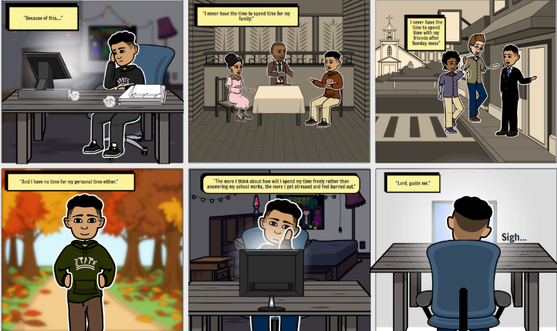

Our topic essentially is about depression and the root of being depressed generally is actually due to his studies maybe He got very low grades or because of to much overthinking about he’s grades and the stand of the church definitely is The man or the person cannot hangout with his friend and family and also cannot actually interact correctly to specifically listen to the gospel of the lord in a generally major way.

**Rationale**

*By Princess Lara Bermudez*

This project promotes awareness on anyone who’s fighting with depression. According to Science Direct, Close to 1 in 10 young adults (8.9%) in the Philippines experience moderate to severe depressive symptoms. Lately, our team observed that students (specifically, junior high school to college students) are struggling with their school works causing them burn outs, anxiety, and even depression. In worsts cases, students usually harm themselves for the sake either for the reason of, it is the way of “comforting” themselves or for the sake of their school works.

As students, our team empathize the struggles of students. So, in this case, we made a comic representation of how it is not easy being a student. Promoting awareness about depression is our team’s aim. Making audience feel that they’re loved and they’re not alone in their rough journey.

**Objectives**

*By Princess Chloe Arimas*

Addressing this common issue to the society.

* In most cases, people are putting to much pressure to students causing sudden symptoms of depression to be present at certain students. It is better to address this problem to those people who expecting students to reach their standards.

Motivates victims to feel positive after learning the project.

* To those who are currently battling with depression, our team would like to lend a hand by showing this project.

Realizing that leaning to God helps you lessen your burden

* To youth, feel free to find your comfort spot to the God. He is always listening and He will never leave your side.

**Solutions**

*By Stephen Barmeso*

Using time effectively, Time the executives is the interaction of getting sorted out and arranging how to split your time between various exercises. Take care of business, and you'll wind up working more efficiently, to accomplish more significantly quicker. quality time, time spent in actually focusing on someone else to fortify a relationship, particularly regarding working guardians and their kid or youngsters. True serenity,

The expression true serenity depicts the psychological condition of peacefulness or assurance you appreciate when liberated from stress.

Keep your primary things your most compelling things by assessing your objectives day by day. Doing as such will keep them at the front of your brain so you can guarantee you will invest your energy and consideration on the most basic errands every day, which will make it simpler to disregard interruptions outside of your objective that could deflect your concentration. Particularly when things are upsetting, a significant number of us resort to remaining in our usual ranges of familiarity doing, saying, watching, or eating things that we definitely know.

**Acknowledgement**

By Fherlyn Marande

First and foremost, We want to express my gratitude to God for providing me with the guidance and chance to pursue my ambitions. We'd also want to express my gratitude to my friends and family for their efforts and support.

**Prayer**

By Fherlyn Marande

Lord Heavenly Father, We confess that we are having a hard time getting through these challenges in our life. We ask you for your forgiveness of our sins. Have mercy on us as you may guide our path to what we deserve. In Jesus name, we pray, Amen.